CYB102 Project 6 (🔗 Instructions Page)

👤 Student Name:
✉️ Student Email:

Reflection (Required)

🤔 Reflection Question #1: If I had to explain “what is a cyber breach” in 3 emojis, they would be…
(Feel free to put other comments about your experience in this unit here, too!)
😈🖥️🔏

🧠Reflection Question #2: Which step of the incident response process do you think is most important?
preparation

📣 Shoutouts: Share appreciation for anyone who helped you out with this project or made your day a little better!
Shout out to my mother in law for helping me around the house to complete my work on time

Required Challenges (Required)

Item #1: A screenshot of your malware case in Catalyst:
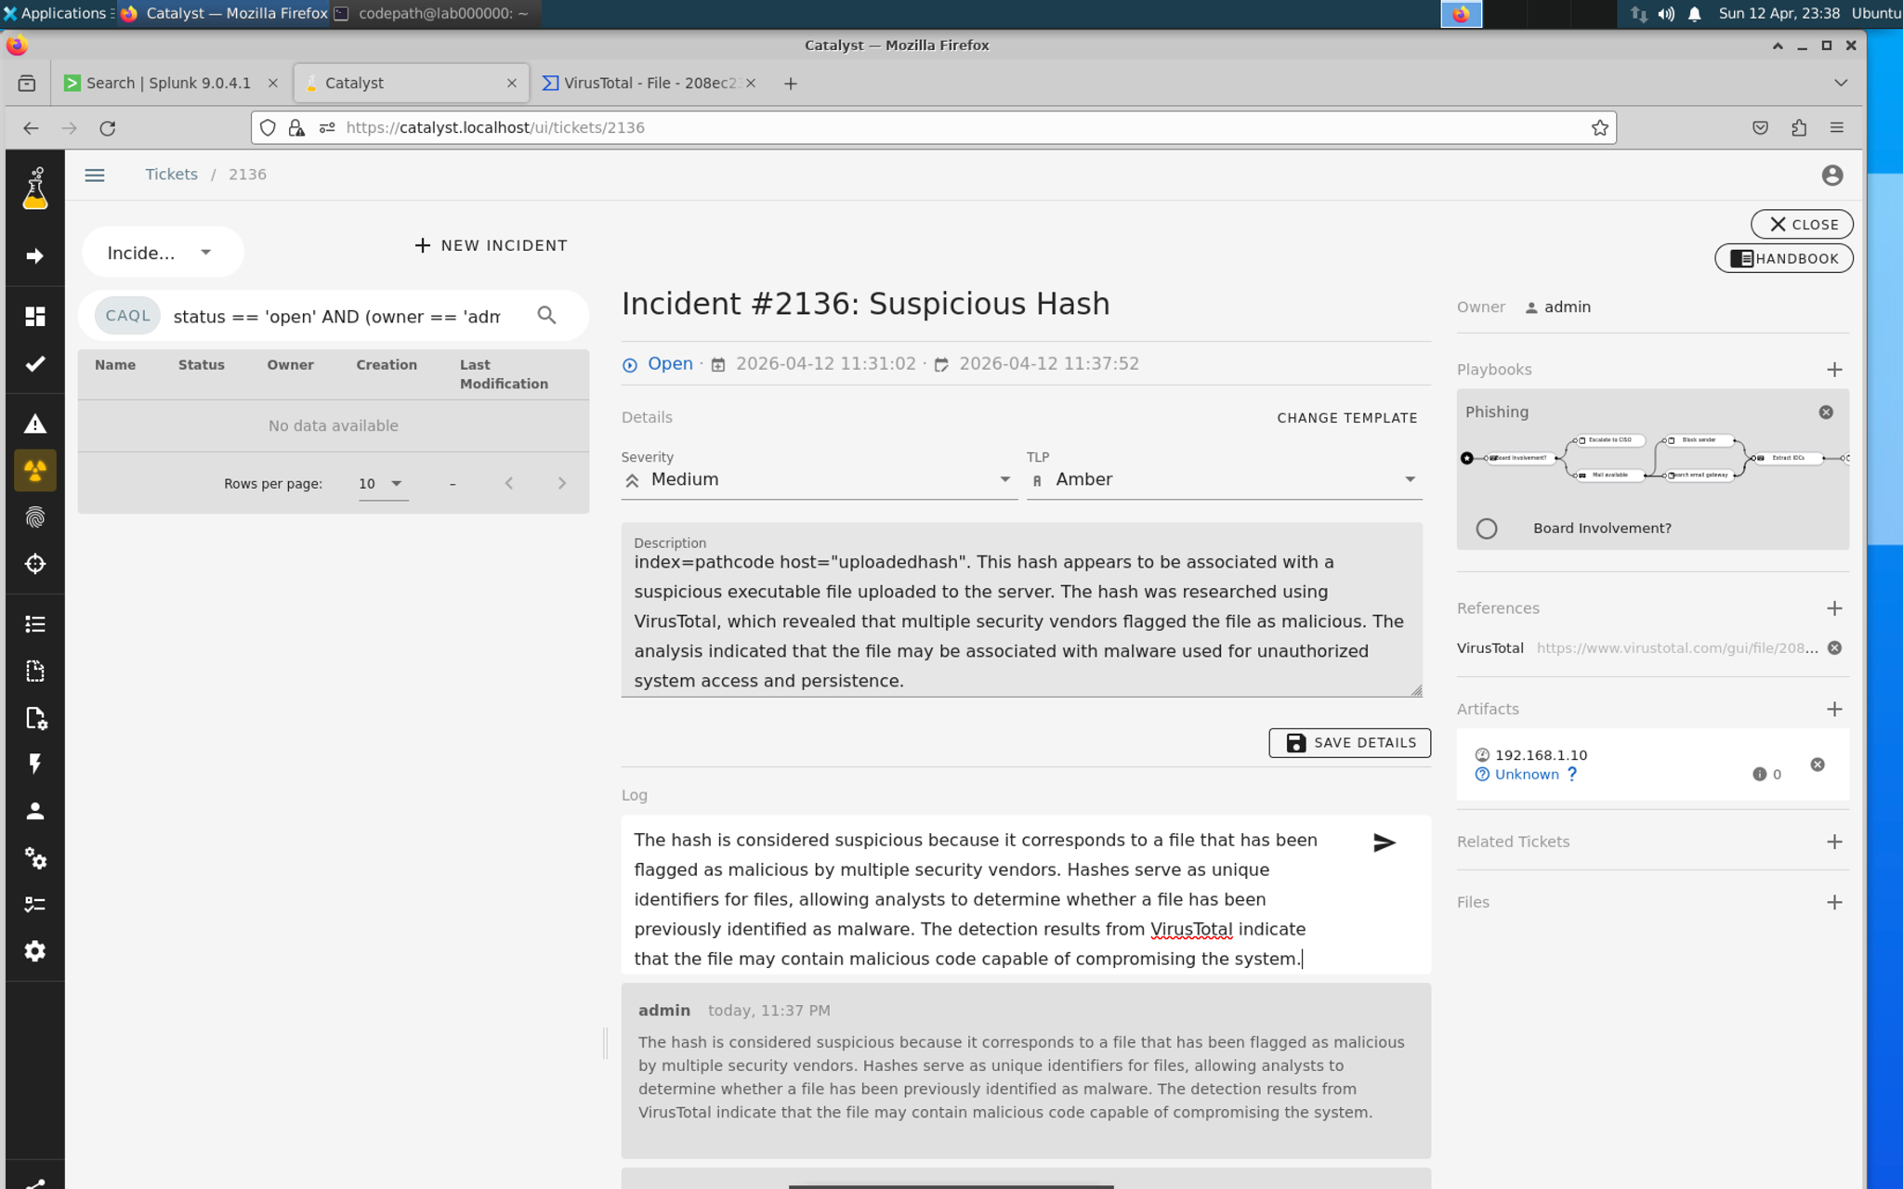

Item #2: At least one artifact and notes from an external source (e.g. VirusTotal, AbuseIPDB):
- Artifact: IP Address 192.168.1.10
- 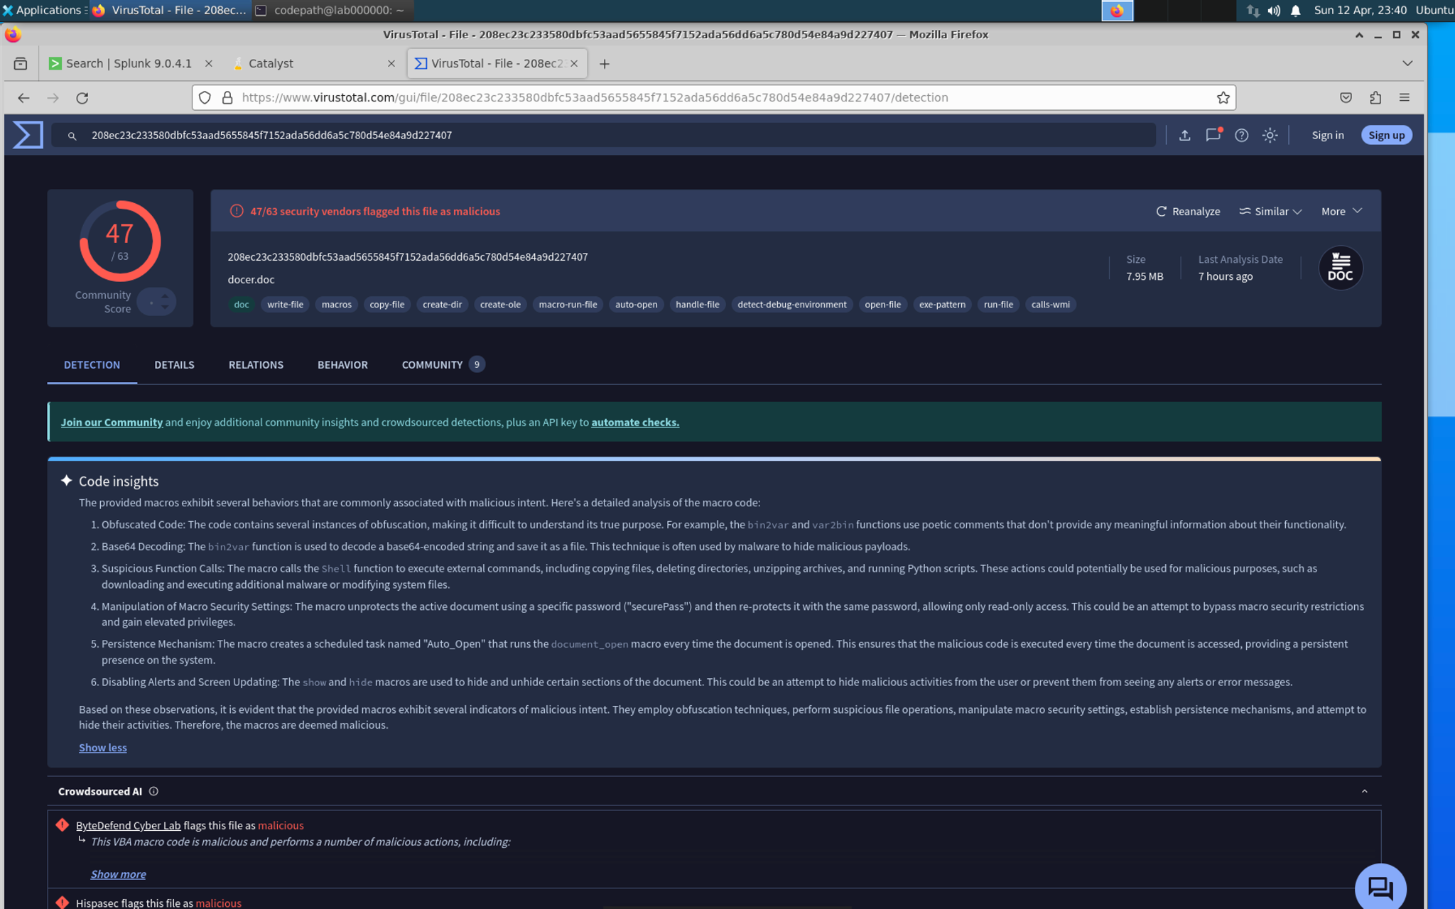

Item #3: A brief write-up of your findings and Lessons Learned:
(Make sure you answer all 3 sub-questions for full credit!)
What was done well?
The incident response team was able to quickly identify suspicious activity by analyzing logs in Splunk. The team successfully detected a malicious artifact and investigated it using external threat intelligence sources such as VirusTotal.
What could have been done better?
Although the suspicious activity was eventually discovered, earlier detection mechanisms could have helped identify the threat sooner. Automated alerts and more proactive monitoring of system logs may have reduced the response time.
What changes can be made to prevent similar incidents in the future?
To prevent similar incidents in the future, organizations should implement stronger security monitoring and automated alerting within their logging systems. Regular threat intelligence checks using tools like VirusTotal can help detect known malicious artifacts more quickly.

Stretch Challenge (Optional)

Bonus Task #1: Catalyst Investigation - Use Catalyst to manage the incident and fill out the case with the Artifacts, Tasks, and TTPs that you researched:
[Insert Screenshot Here]

Bonus Task #2: NIST or SANS Framework Analysis - Write a report that outlines the steps of either the NIST or SANS framework and how it could have prevented the breach:
TODO

Submission Checklist
👉Check off each of the features you have completed. You will only be graded on the features you check off.

Required Challenges
- Item #1
- Item #2
- Item #3

Stretch Challenge
- Bonus Task #1
- Bonus Task #2

💡Tip: You can see specific grading information, including points breakdown, by going to 🔗 the grading page on the course portal.

Submit your work!
Step 1: Click the Share button at the top of your screen double check that anyone with the link can edit.

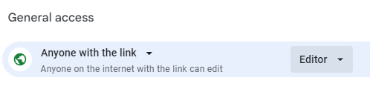

Step 2: Copy the link to this document.
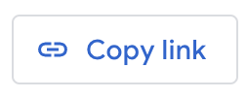

Step 3: Submit the link on the portal.

